**PROJECT REPORT**



**CRYPTEX**Cryptocurrency Trading Simulator

|  |  |
| --- | --- |
| Course Code | CS2005- Database Systems |
| Instructor | Dr. Anam Qureshi |
| Project Team | Muhammad Mushtaq K213273  Qusai Ezzy K214866  Muhammad Shaheer Luqman K214655 |

Introduction

The Cryptex cryptocurrency website project is a forward-thinking initiative focused on the development of an advanced platform for cryptocurrency trading and investment. Motivated by the goal of creating an innovative solution that aligns with the evolving needs of the dynamic cryptocurrency market, Cryptex aims to redefine the user experience in digital asset management.

Motivation:

Cryptex draws inspiration from the recognition of existing gaps and opportunities within current cryptocurrency platforms. Recognizing the limitations of some solutions in terms of features and user-friendliness, our project is motivated to address these shortcomings. Cryptex strives to introduce novel functionalities, intuitive interfaces, and a secure infrastructure to set a new standard for cryptocurrency platforms, offering users a distinctive and compelling experience.

Significance in the Cryptocurrency Market:

In the broader context of the cryptocurrency market, Cryptex holds significant promise. Firstly, the project seeks to enhance the user experience through the incorporation of state-of-the-art technologies, responsive design, and user-centric features. Secondly, Cryptex aims to contribute to the overall ecosystem by promoting accessibility and inclusivity, making digital asset participation more user-friendly for both novice and experienced users.

Moreover, Cryptex places a strong emphasis on security, transparency, and innovation, aligning with the industry's growing need for reliable and trustworthy platforms. As the cryptocurrency market continues to expand, Cryptex aspires to play a pivotal role in shaping a mature and sophisticated environment for digital asset trading and investment. In essence, the project not only aims to meet existing market expectations but also endeavors to establish new benchmarks for excellence in the ever-evolving landscape of cryptocurrency services.

# Problem Statement

Challenges in the Cryptocurrency Market:

1. Complex User Interfaces:
   * Many existing cryptocurrency platforms have complex and intimidating user interfaces, hindering the onboarding of new users and limiting accessibility.
2. Limited Features for Novice Traders:
   * Some platforms lack user-friendly features tailored for novice traders, making it challenging for beginners to navigate and understand the intricacies of cryptocurrency trading.
3. Security Concerns:
   * Security remains a persistent concern in the cryptocurrency market. Instances of hacking, fraud, and data breaches have eroded trust among users.
4. Fragmented User Experience:
   * Cryptocurrency traders often need to use multiple platforms to access different cryptocurrencies, leading to a fragmented user experience.

Relevance of Replicating Binance:

1. Proven Success Model:
   * Binance has emerged as a market leader with a proven track record of success. Replicating Binance's model is relevant as it allows us to leverage a well-established and successful framework.
2. User Familiarity:
   * Binance has set a standard in the industry, and users are familiar with its interface and functionalities. Replicating Binance provides a sense of familiarity to users, reducing the learning curve and enhancing user adoption.
3. Market Demand:
   * Binance's popularity underscores the demand for a platform with comprehensive features, diverse cryptocurrency support, and a user-friendly interface. Replicating Binance is relevant to meet this demand.

Gaps in Existing Cryptocurrency Platforms:

1. Lack of Intuitive Design:
   * Many platforms lack an intuitive design, making it difficult for users to navigate and execute trades efficiently.
2. Insufficient Educational Resources:
   * Novice traders often struggle due to the absence of educational resources on existing platforms. Cryptex aims to bridge this gap by offering comprehensive educational tools.
3. Limited Cryptocurrency Coverage:
   * Some platforms have limited cryptocurrency offerings, restricting users' choices. Cryptex intends to provide a broader range of supported cryptocurrencies to meet diverse user preferences.
4. Inadequate Security Measures:
   * Security vulnerabilities persist in some platforms. Cryptex is committed to implementing robust security measures, including advanced encryption and authentication protocols, to ensure the safety of user assets.

By addressing these challenges and drawing inspiration from Binance's success, Cryptex aims to create a platform that not only meets current market expectations but also sets new standards for accessibility, security, and user satisfaction in the cryptocurrency space.

# Entity Relationship Diagram

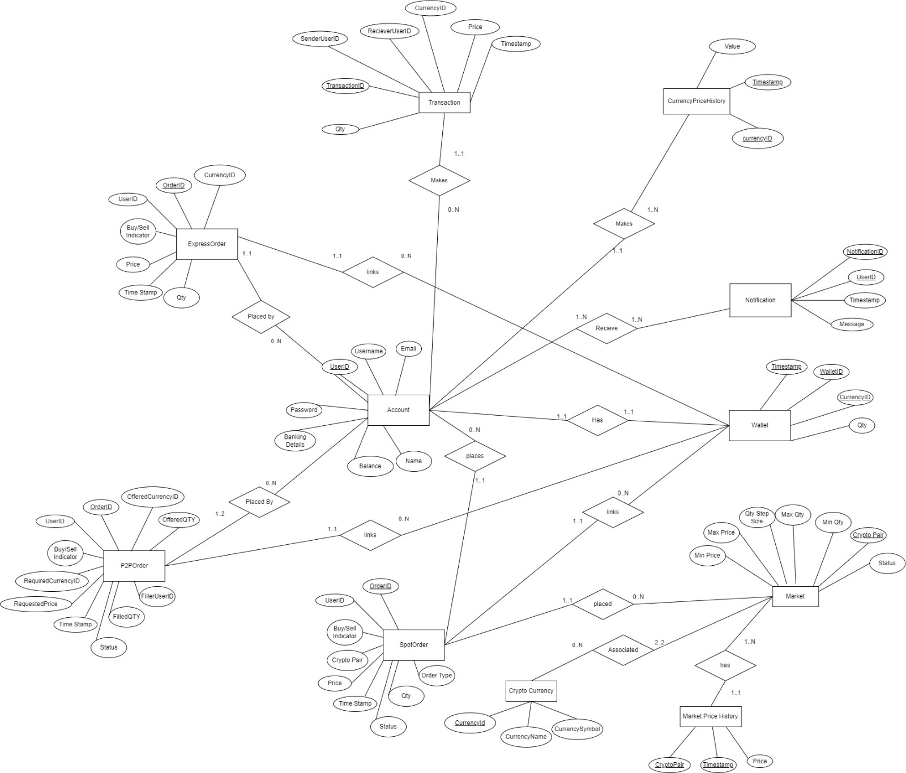

# Relational Schema

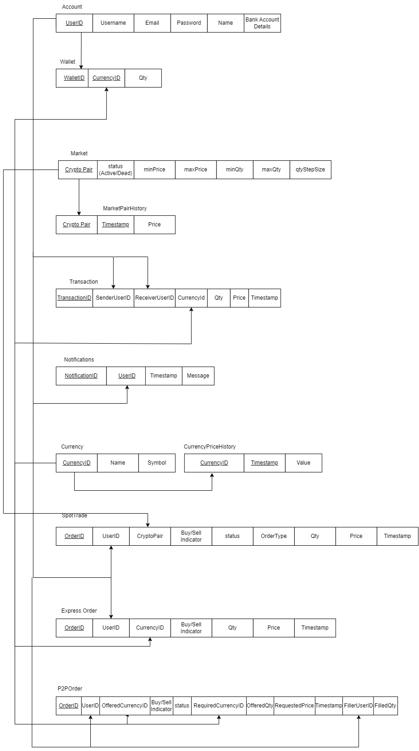

# Technologies Used in The Project

In the development of our crypto trading website, we employed a variety of cutting-edge technologies to ensure a seamless and secure user experience. The integration of these technologies played a crucial role in the functionality and overall success of the project. Here is an overview of the key technologies utilized:

**1. React JavaScript:**

- React served as the foundation for the user interface, allowing us to create dynamic and responsive components. Its component-based architecture facilitated the development of a modular and maintainable front end.

**2. API Integration:**

- We leveraged various APIs to fetch real-time market data, execute trades, and provide users with up-to-date information on cryptocurrency prices and trends. API integration played a pivotal role in ensuring that our platform delivers accurate and timely data.

**3. MySQL Database:**

- MySQL was chosen as the relational database management system to store and manage user data, transaction history, and other critical information securely. Its reliability and scalability were instrumental in handling the dynamic nature of crypto trading.

**4. Apache Web Server:**

- Apache served as the web server, handling HTTP requests and responses efficiently. Its robust performance and versatility made it a suitable choice for hosting our website and managing the flow of information between clients and servers.

**5. XAMPP:**

- XAMPP, with its bundled Apache, MySQL, and PHP, provided a comprehensive and easy-to-install development environment. This allowed our team to collaborate seamlessly during the development phase and ensured consistency across different environments.

**6. HTML (HyperText Markup Language):**

- HTML was employed to structure the content of our web pages, defining the layout and elements that make up the user interface. Its simplicity and compatibility with various browsers contributed to a consistent and user-friendly design.

**7. Express.js:**

- Express.js, a Node.js web application framework, was used to build the server-side logic of our application. It facilitated the creation of robust APIs and streamlined the handling of backend operations, contributing to the overall efficiency and performance of the website.

**8. Chart Libraries:**

- To enhance the visual representation of market data and trends, we utilized advanced charting libraries. The inclusion of these libraries allowed us to present complex financial information in a clear and comprehensible manner, empowering users with valuable insights for informed decision-making.

These technologies collectively empowered us to develop a feature-rich crypto trading platform that not only meets the functional requirements but also provides users with a secure and enjoyable experience in the dynamic world of cryptocurrency trading.

# Potential Users of The Project

**Target Audience:**

1. Cryptocurrency Traders:
   * Definition: Individuals actively involved in buying and selling cryptocurrencies for short-term gains.
   * Features & Functionalities: Advanced trading tools, real-time market data, customizable dashboards, and a user-friendly interface for quick and efficient trading.
2. Cryptocurrency Investors:
   * Definition: Individuals who hold cryptocurrencies for the long term with a focus on capital appreciation.
   * Features & Functionalities: Portfolio management tools, in-depth analytics, and educational resources to support informed investment decisions.
3. Crypto Enthusiasts:
   * Definition: Individuals interested in the cryptocurrency space, seeking information, community engagement, and occasional trading.
   * Features & Functionalities: Newsfeed with real-time updates, educational content, discussion forums, and a user-friendly interface for easy navigation.
4. Novice Traders:
   * Definition: Beginners who are new to cryptocurrency trading and investment.
   * Features & Functionalities: User-friendly interface, educational resources, simulated trading (demo accounts), and tooltips for guidance.
5. Institutional Investors:
   * Definition: Large-scale investors, including hedge funds and institutional entities, involved in cryptocurrency markets.
   * Features & Functionalities: Advanced trading APIs, institutional-grade security, high liquidity, and customizable account management.

**How Features Cater to Different User Groups:**

1. Tailored User Interfaces:
   * Cryptex provides a customizable dashboard allowing users to arrange and prioritize features based on their preferences, catering to both experienced traders and beginners.
2. Advanced Trading Tools:
   * Traders and institutional investors have access to advanced tools such as technical analysis charts, order book depth, and algorithmic trading options, enhancing their ability to make strategic decisions.
3. Portfolio Management:
   * Investors can track their portfolio's performance over time, set investment goals, and receive personalized insights, providing a holistic view of their cryptocurrency holdings.